Biology Revision

Pages 2–3

Scientific research

1 Which scientist is called the ‘father of genetics’?

|  |
| --- |
|  |

2 What is the term used today to describe Mendel’s ‘factors’?

|  |
| --- |
|  |

3 Name the two important principles Mendel identified that form the basis of genetics today.

|  |
| --- |
|  |
|  |

4 If you inherit your curly hair from your father, does this mean you will also inherit your father’s blue eyes? Give a reason for your answer.

|  |
| --- |
|  |
|  |
|  |
|  |

5 Watson and Crick described the structure of DNA as a double helix. What does this mean?

|  |
| --- |
|  |
|  |

7 Match the scientists with the correct contribution they gave to genetics.

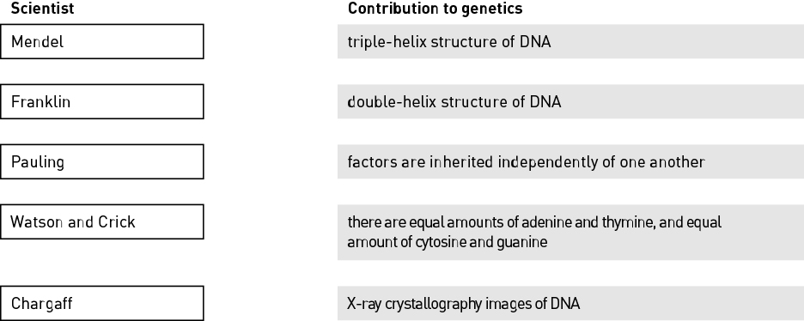

Pages 4–5

The composition of DNA

1 Name the chemical that all genes are made up of.

|  |
| --- |
|  |

2 Name the four complementary nitrogen bases.

|  |
| --- |
|  |

3 Identify the type of cell that contains no DNA.

|  |
| --- |
|  |

4 Label the three components of the nucleotide shown below.

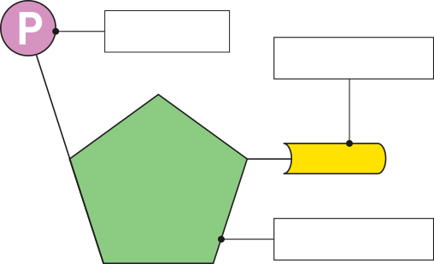

5 Fill in the blanks.

The bases adenine and thymine are joined by hydrogen bonds, while cytosine and guanine are joined by hydrogen bonds.

6 Describe the two vital roles of a DNA molecule.

|  |
| --- |
|  |
|  |
|  |
|  |

7 A strand of DNA has the base sequence AATGCGATGC. Give the base sequence for the complementary strand.

|  |
| --- |
|  |

Nitrogen bases always exist as complementary base pairs within a DNA molecule. Adenine is always paired with thymine, while cytosine is always paired with guanine.

8 Consider a particular gene with a total of 100 bases. If 24 of these bases are adenine, how many thymine, cytosine and guanine bases would there be?

|  |
| --- |
|  |
|  |
|  |

1. Label the parts of the microscope below.

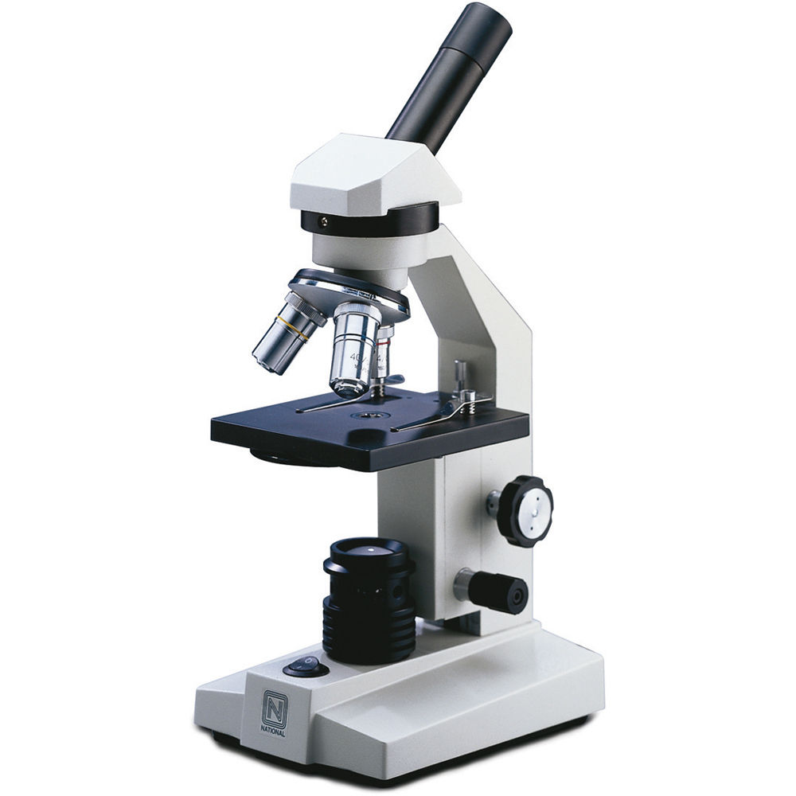

Word Bank: Stage, light, eyepiece lens, arm, coarse focus, objective lens, fine focus, base